Uploa ding your web project a s s ignm ents- An expa nded wa lkthrough

Each chapter, there will be a project for you to create, upload to your student server, and submit to Canvas. We will be using GitHub for our web server. You will need to log in to GitHub with your username and password to submit your projects.

Here's a step-by-step guide to doing just that:

**To submit assignments, follow the steps below:**

1. Create a folder on your computer where you can keep your work. Most people name it “WEB 110”.

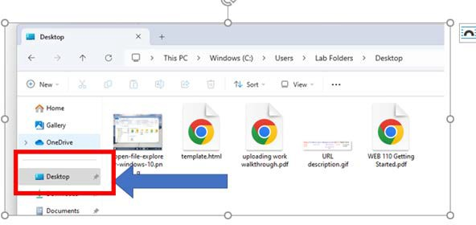

Create your web page and create an HTML comment and/or a CSS comment at the top of the document. Save it to the folder you just created. Make sure your file has .htm or .html at the end (For ex, hello.htm or .html)

* + You will not be able to see a .txt file. That's a text file and not a valid web file.
  + Remember to validate your files, add comments at the top of the document, and indent your code to keep it readable.

1. Connect GitHub and log in with your username and password.

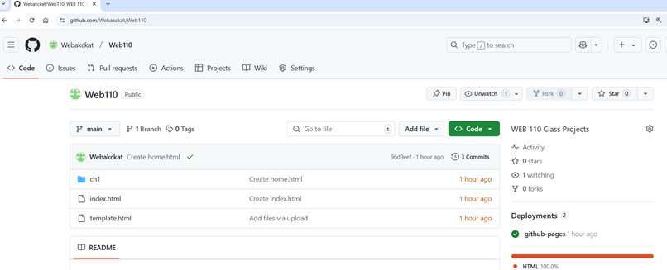

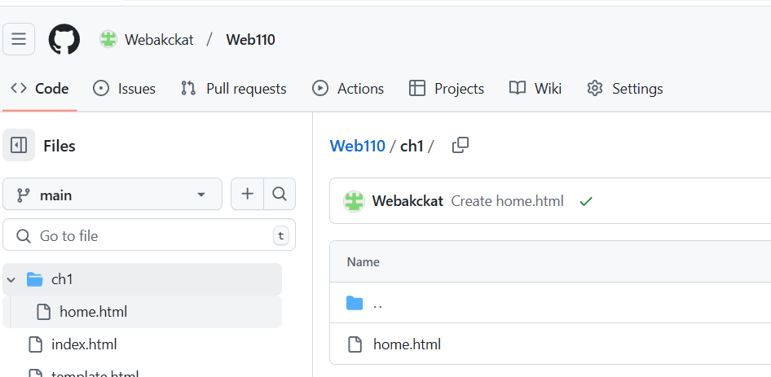**Open the folder where you want the file to be located. Ex: ch1 folder**

•

Each chapter will need a folder on your web server.

You can also create new folders by simply dragging and dropping a folder with files to your repository on GitHub and then uploading them. If you want the folder you’re uploading to be inside a specific sub-folder, be sure to click on and enter that sub-folder before uploading your files. You can find your website in Github by clicking the Code link [in the navigation at the top,](https://www.youtube.com/watch?v=IU_hMoVz_Pc) and look [for Deployments.](https://www.youtube.com/watch?v=IU_hMoVz_Pc)

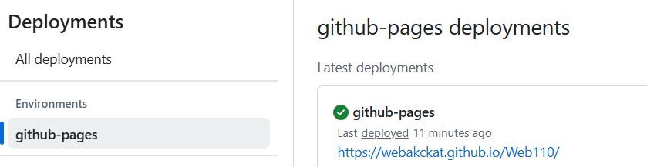

1. Open your web browser (Chrome, Microsoft Explorer, etc..) and type in the URL to your web page (from step 3).

**REMEMBER: All projects we do this semester will start with https://username.github.io**

**(where “username” is replaced by your username**

**My homework for Ch.1 would be: https://webakckat.github.io/Web110/ch1/hello.html**

**A Web developer “best practice” is to name all Web folders and files using lowercase without spaces.**

1. Lastly, you can open Canvas and click Submit assignment.
2. Type the URL into the box at the bottom of the page. (See the screenshot below).

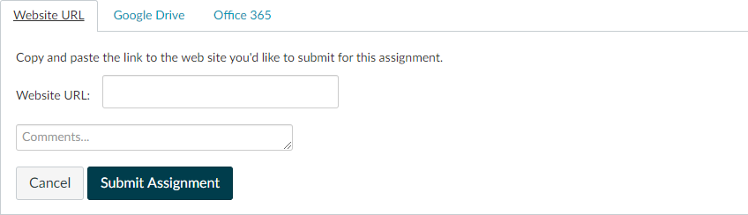

Put the webpage link here

https://username.github.io/Web110/ch1/hello.html

where usrename is replaced by your username

1. Click Submit Assignment.

**You did it!**

**I hope this helps. Let me know if you have any more questions. Good luck!**

**Allison**